Good UX/UI experience: [Digital Wallets, Money Management, and More | PayPal US | PayPal US](https://www.paypal.com/us/home)

The website and mobile app design is clean, presenting information without the need for fancy graphics or unnecessary features. This website has a streamlined interface making it easier for users to find specific functions, such as copying invoices or generating reports.

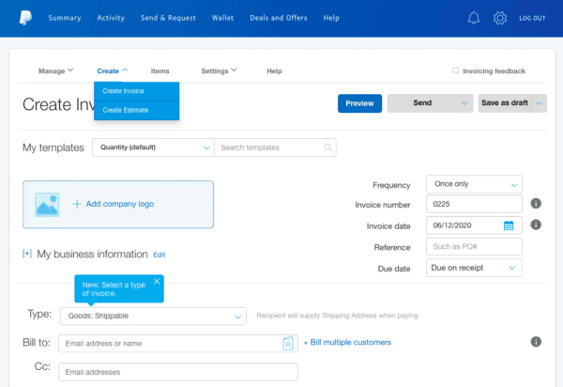

Bad UX/UI experience: <https://userinyerface.com/>

This game is the worst user experience I’ve ever came across on the internet. This is a short web game that shows what happens when every frustrating user interface design is jammed together. Buttons that should be clickable aren’t, drop-down menus are sorted incorrectly, etc. The massive button that says “NO” does nothing. The actual answer, clicking on “HERE,” is the button that takes you to the next page.

